**OPERATIONS FORENSIC – VENSIM SIMULATION**

**GROUP 3 – Bhoomi, Divya, Rajat, Nicole**

In our project, referring to the book titled World Dynamics published by Jay W Forrester, we have tried to model the World Dynamics using Vensim. Author has used five variables, but we have used only three variables in our project namely; population, capital investment and natural resources.

The use of computer simulation was revolutionary at the time of Forrester's work. It allowed for the analysis of complex systems in ways that were not possible before. Through simulation, Forrester could test various scenarios and predict potential future outcomes based on different assumptions and policy decisions. This aspect of the work highlighted the potential unintended consequences of policies that fail to consider the system's interconnected nature.

Population

We have modelled population growth based on two feedback loops: a positive loop that increases population growth and a negative loop that decreases population growth. The positive loop is based on the idea that an increase in population will lead to an increase in the number of births, which will further increase the population. The negative loop is based on the idea that an increase in population will lead to an increase in the number of deaths, which will decrease the population. The strength of these two loops will determine whether the population grows or declines.

The model also includes a number of other factors that can affect population growth, such as the food supply, the material standard of living, crowding, and pollution. These factors are represented by multipliers that can increase or decrease the normal birth and death rates.

The model is able to generate a variety of population growth patterns, depending on the values of the parameters. For example, if the birth rate is high and the death rate is low, the population will grow rapidly. If the birth rate is low and the death rate is high, the population will decline.

The model can also be used to explore the effects of different policies on population growth. For example, a policy that increases the food supply or the material standard of living is likely to lead to an increase in population growth. A policy that reduces the food supply or the material standard of living is likely to lead to a decrease in population growth.

Capital Investment

Capital investment is modelled as a level variable in the system dynamics model. It is affected by two main factors: capital-investment generation and capital-investment discard.

Capital-investment generation is a positive feedback loop, meaning that it is self-reinforcing. The more capital investment there is, the more capital investment is generated. This is because capital investment leads to increased production, which in turn leads to more capital investment. However, this loop is limited by the capital-investment multiplier, which decreases as the amount of capital investment increases. This means that the rate of capital-investment generation eventually slows down and reaches a steady state.

Capital-investment discard is a negative feedback loop, meaning that it counteracts the positive feedback loop of capital-investment generation. The more capital investment there is, the more capital investment is discarded. This is because capital investment eventually wears out and needs to be replaced. The rate of capital-investment discard is determined by the capital-investment discard rate, which is a constant.

The overall effect of these two loops is to keep the level of capital investment relatively stable.

Natural Resources

Natural resources are modelled as a finite quantity that is depleted over time. The rate of depletion is determined by the usage rate of natural resources.

The model includes a level variable for natural resources, which represents the total amount of natural resources available at any given time. This level variable is affected by two main factors:

* Natural resource inflow: This is a positive feedback loop, meaning that it increases the level of natural resources. The rate of natural resource inflow is determined by the natural resource inflow rate, which is a constant.
* Natural resource outflow: This is a negative feedback loop, meaning that it decreases the level of natural resources. The rate of natural resource outflow is determined by the usage rate of natural resources, which is a function of the level of capital investment and the level of population.

The overall effect of these two loops is to keep the level of natural resources relatively stable in the absence of any major changes in the usage rate of natural resources. However, if the usage rate of natural resources increases significantly, the level of natural resources will eventually decline.

This can have a number of negative consequences, including:

* Increased pollution: As natural resources are depleted; the level of pollution will increase. This is because pollution is a by-product of the extraction and use of natural resources.
* Decreased economic growth: As natural resources become scarcer, they will become more expensive. This can lead to decreased economic growth, as businesses are forced to pay more for the resources, they need to produce goods and services.
* Social unrest: As natural resources become scarcer, there may be social unrest as people compete for access to these resources.

It is therefore important to use natural resources wisely and to find ways to reduce our dependence on them.

The Author uses a system of differential equations to model the interactions between these five levels. The equations are based on the principles of systems dynamics, which is a branch of engineering that deals with the modelling and analysis of complex systems.

The model is able to reproduce a number of historical trends, such as the growth of population, the depletion of resources, and the increase in pollution. The model can also be used to predict future trends, such as the potential for a global collapse.

One of the key messages from "World Dynamics" is the need for comprehensive and anticipatory policymaking. Forrester argued that many contemporary policies were inadequate for preventing systemic collapse, as they often addressed issues in isolation rather than considering the system as a whole. His work advocated for more integrated approaches to policymaking, considering the long-term impacts and interactions among different system components. The model underscores the need for policies that simultaneously address multiple aspects of the world system.

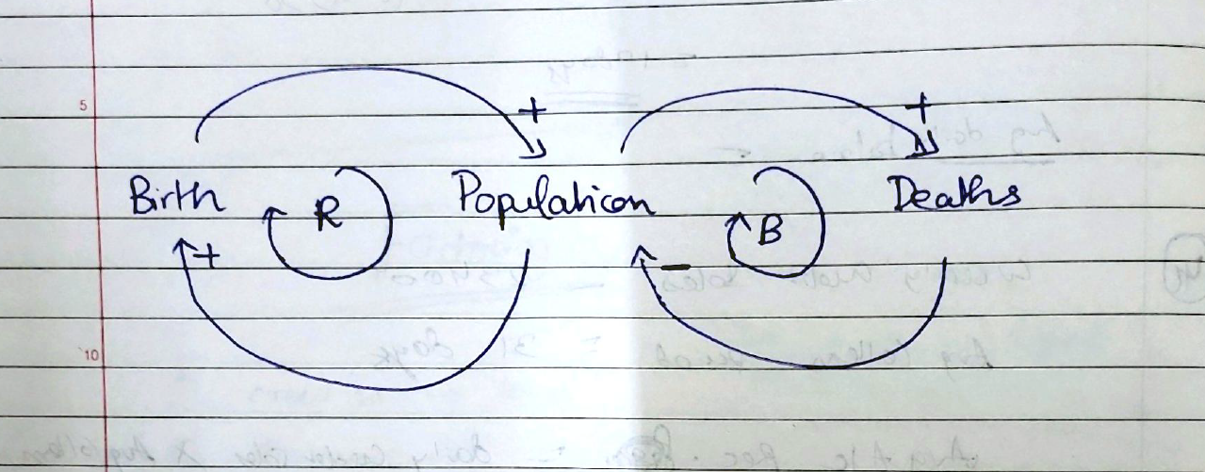

Birth and Population form a reinforcing loop, while death and population form a balancing loop.

The principal governing equations and influencing factors in the model are:

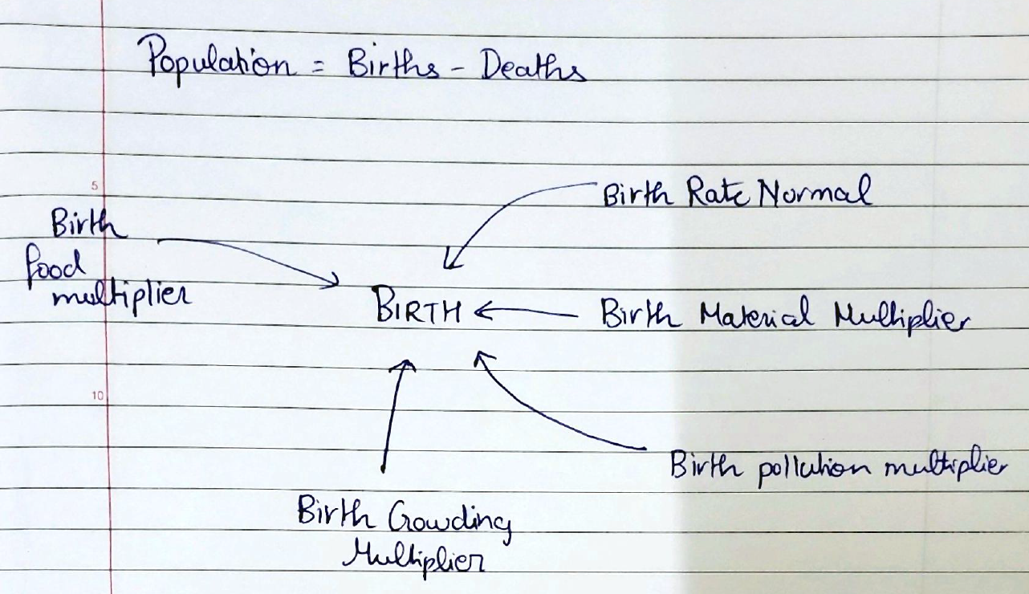

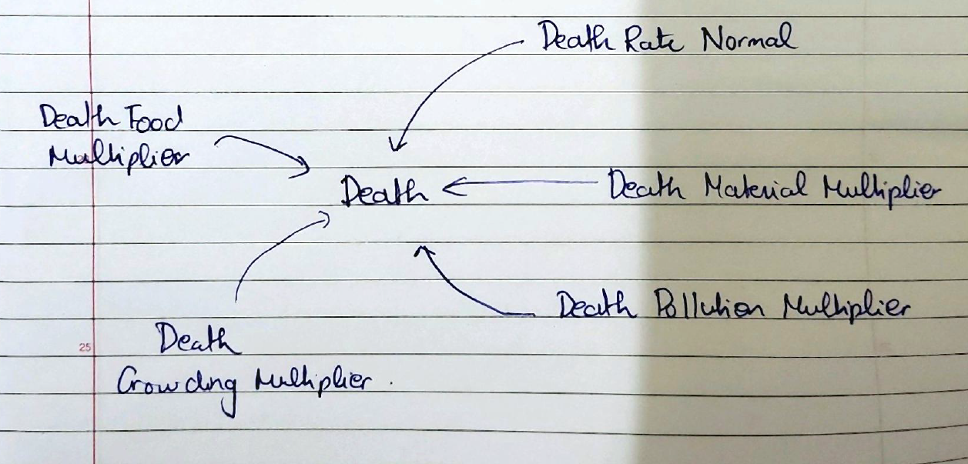

The estimated world population using the original model is 5.25 billion in 2023.

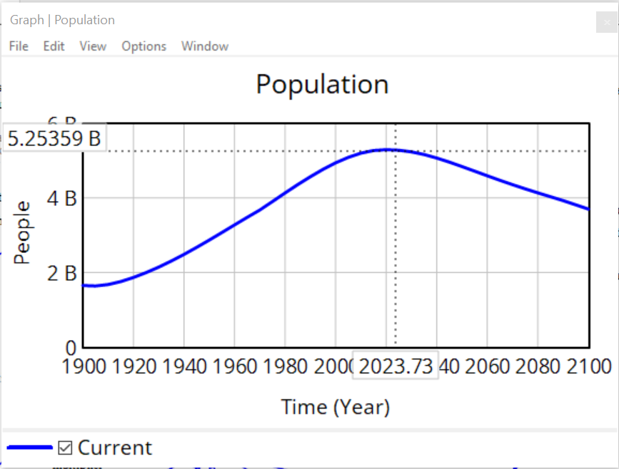

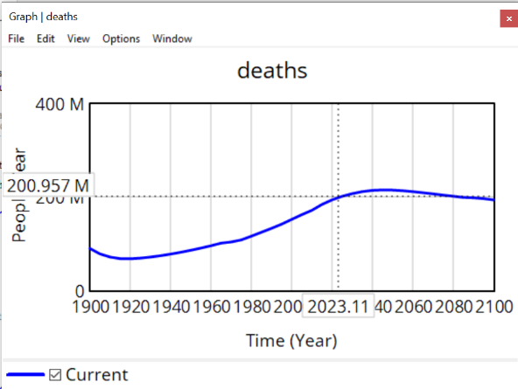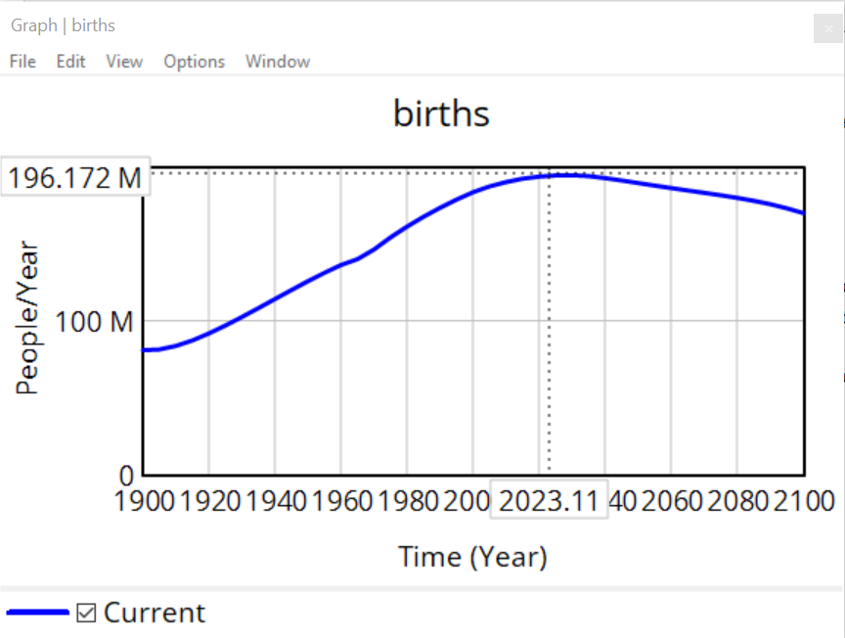

The birth rate in the first model was 0.04 and the death rate was 0.028. By revising this the birth rate to 0.08 and the death rate to 0.015, a population at 7.56 billion was predicted for 2023. This is closer to the current actual population of 8.1 billion.

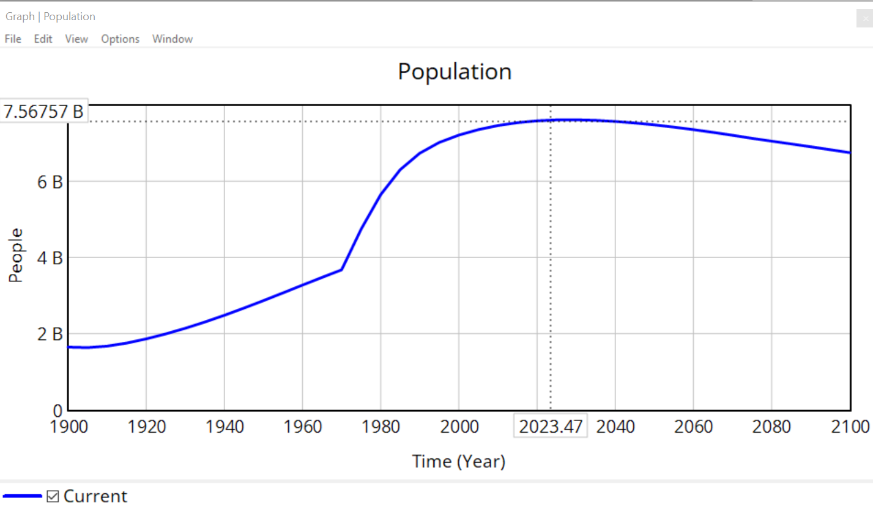

Now we vary the pollution per capita parameter to see its impact on deaths pollution multiplier which then impacts the deaths. The pollution per capita was initially set to 1 post 1970. By raising it to 1.5 (50% increase) we see population to decrease to 7.35 billion (2.7% drop).

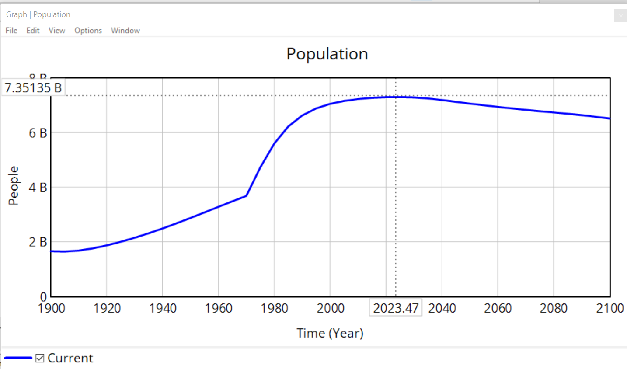

Therefore, we can observe the drastic balancing impact pollution has on world population.

Conclusion

Despite its significant contributions, "World Dynamics" also faced criticism, particularly regarding the accuracy of its predictions and the simplifications inherent in the model. Critics argued that the model might oversimplify complex social, economic, and environmental factors. However, these criticisms also spurred further research and refinement in the field of system dynamics.

In conclusion, Jay W. Forrester's "World Dynamics" represents a seminal work in the field of system dynamics and global modelling. It introduced a novel way of understanding and simulating the complexities of the world system, emphasizing the interconnectedness and dynamic nature of global issues. The use of computer simulation to explore these dynamics marked a significant advancement in the field, offering insights and predictions that continue to influence policy and scientific research in understanding global sustainability challenges.